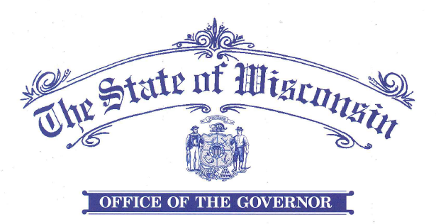

EXECUTIVE ORDER #81

Relating to a Proclamation that the Flag of the United States and the Flag of the State of Wisconsin be Flown at Half-Staff as a Mark of Respect for Army Cpl. Francis J. Rochon of the United States Army Who Lost His Life in the Korean War
WHEREAS, Army Cpl. Francis J. Rochon, of Superior, a veteran of the Korean War and a member of the United States Army assigned to Company C, 1st Battalion, 23rd Infantry Regiment, 2nd Infantry Division, was reported missing in action on September 1, 1950, near Changnyeong, South Korea;
WHEREAS, Army Cpl. Francis J. Rochon’s remains were buried in the United Nations Military Cemetery in Tanggok, South Korea in 1951, and reinterred five years later at the National Memorial Cemetery of the Pacific in Honolulu, Hawaii;
WHEREAS, in 2018, Army Cpl. Francis J. Rochon’s remains were sent to the Defense POW/MIA Accounting Agency laboratory for analysis and identification, and on June 18, 2020, Army Cpl. Francis J. Rochon was accounted for;
WHEREAS, Army Cpl. Francis J. Rochon was awarded the Purple Heart, Good Conduct Medal, National Defense Service Medal, Korean Service Medal, United Nations Service Medal, and Combat Infantryman Badge;
WHEREAS, on Saturday, July 25, 2020, Army Cpl. Francis J. Rochon will be buried with full military honors in Foxboro, Wisconsin; and
WHEREAS, the people of the United States and the State of Wisconsin are forever grateful for the service, selflessness, and sacrifice of Army Cpl. Francis J. Rochon of the United States Army.
NOW, THEREFORE, I, TONY EVERS, Governor of the State of Wisconsin, by the authority vested in me by the Constitution and the laws of the State, hereby order that the flag of the United States and the flag of the State of Wisconsin shall be flown at half-staff at all buildings, grounds, and military installations of the State of Wisconsin equipped with such flags beginning at sunrise on Saturday, July 25, 2020, and ending at sunset on that date.
IN TESTIMONY WHEREOF, I have hereunto set my hand and caused the Great seal of the State of Wisconsin to be affixed. Done at the Capitol in the City of Madison this twenty-first day of July in the year of two thousand twenty.

TONY EVERS
Governor
By the Governor:

DOUGLAS LA FOLLETTE
Secretary of State

